Wes Rupert – 2/11/13  
EECS 345 – Hw 02

1. <S> → <V> = <Q> | <Q>  
   <V> → x | y | z  
   <Q> → <O> ? <Q> : <Q> | <O>  
   <O> → <O> || <A> | <A>  
   <A> → <A> && <N> | <N>  
   <N> → ! <P> | <P>  
   <P> → ( <S> ) | <B>  
   <B> → true | false
   1. Yes. See Fig. 1
   2. No. You cannot have two ‘y’s in a row, as <A> y → x <A> y | x y, which only has <A> y and x y substrings.
   3. No. Since the ‘y’s must be paired with the ‘x’s to become ‘<S>’s, there is no way to group two consecutive ‘<S>’s.
   4. No. Since the ‘y’s must be paired with the ‘x’s to become ‘<S>’s, and the second ‘w’ must be paired with the ‘xyz’ (<S> → w <S> <B> and <B> → z), there is no way to group two consecutive ‘<S>’s.
   5. Yes. See Fig. 2
2. 1. // Precondition: x < 2 \* y  
      y = y - x // x > -2 \* (y - x) → x > 2 \* x - 2 \* y  
      x = x + 2 \* y // x + 2 \* y > 0 → x > -2 \* y  
      // Postcondition: x > 0
   2. // Precondition: x ≥ 0 && a \* a \* x ≥ 2 \* b  
      if (a < 0) then // Since a < 0, ⇒ a \* a \* x ≥ 2 \* b  
       y = a \* a \* x - b // a \* a \* x - b ≥ b → a \* a \* x ≥ 2 \* b  
      else // Since a ≥ 0, ⇒ x ≥ 0  
       y = a \* x + b // a \* x + b ≥ b → a \* x ≥ 0  
      // Postcondition: y ≥ b
   3. // Precondition: A[p] < A[i] < A[q]  
      if A[i] < low then // Since A[i] < low, ⇒ low ≤ high < A[q]  
       p = p + 1 // A[i] < low ≤ high < A[q]  
       t = A[i] // A[i] < low ≤ high < A[q]  
       A[i] = A[p] // t < low ≤ high < A[q]  
       A[p] = t // t < low ≤ high < A[q]  
       i = i + 1 // A[p] < low ≤ high < A[q]  
      else if A[i] > high then // Since A[i] > high, ⇒ A[p] < low ≤ high  
       q = q - 1 // A[p] < low ≤ high < A[i]  
       t = A[i] // A[p] < low ≤ high < A[i]  
       A[i] = A[q] // A[p] < low ≤ high < t  
       A[q] = t // A[p] < low ≤ high < t  
      else // Since A[i] > low && A[i] < high, ⇒ A[p] < A[i-1] < A[q]  
       i = i + 1 // A[p] < low ≤ high < A[q]  
      // Postcondition: A[p] < low ≤ high < A[q]
3. // Precondition: n ≥ 0 and A contains n elements indexed from 0  
   bound = n - 1;  
   while (bound > 0) {  
    // Let l = {A[bound] ≤ A[bound + 1] ≤ ... ≤ A[n - 1]}  
    t = 0;  
    for (i = 0; i < bound-1; i++) { // Precondition:   
    // Precondition: none  
    if (A[i] > A[i+1]) { // Precondition: A[i] ≥ A[i+1]  
    swap = A[i]; // A[i+1] ≤ A[i]  
    A[i] = A[i+1]; // A[i+1] ≤ swap  
    A[i+1] = swap; // A[i] ≤ swap  
    t = i+1; // We swapped, so t = i+1, index of larger A[x]  
    }  
    // Postcondition: A[i] ≤ A[i+1]  
    }  
    // Postcondition: A[i] ≤ A[i+1] ≤ ... ≤ A[bound]  
    bound = t; // t is highest index of swap  
   }  
   // Postcondition: A[0] ≤ A[1] ≤ ... ≤ A[n-1]  
     
   Let A[x:y] be the array {A[x], A[x+1], ..., A[y-1], A[y]}  
     
   Inner loop - let l={A[bound] = max(A[0:bound])}  
   Case 0: bound = 0  
    A[0] = max(A[0:0])  
   Case k+1: Assume A[k] = max(A[0:k])  
    If A[k] ≤ A[k+1], the if statement doesn't execute, and A[k+1] = max(A[0:k+1])  
    If A[k] > A[k+1], the if statement swaps them, and A[k+1] = max(A[0:k+1])  
     
   Outer loop - Let l={A[bound]≤A[bound+1]≤...≤A[n-1]}  
   Case 0: bound = n-1  
    A[n-1]≤A[n-1]  
   Case t-1: Assume {A[t]≤A[t+1]≤...≤A[n-1]}  
    Since inner loop moves the maximum value of A[0:t-1] to the t-1 index, A[0:t-1] ≤ A[t:n-1]  
    Since the for loop makes A[t-1] = max(A[0:t-1]), {A[t-1] ≤ A[t] ≤ ... ≤ A[n-1]}

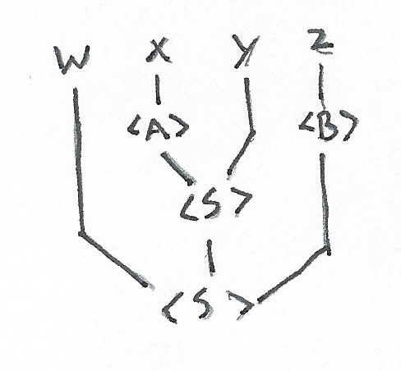

Fig. 1

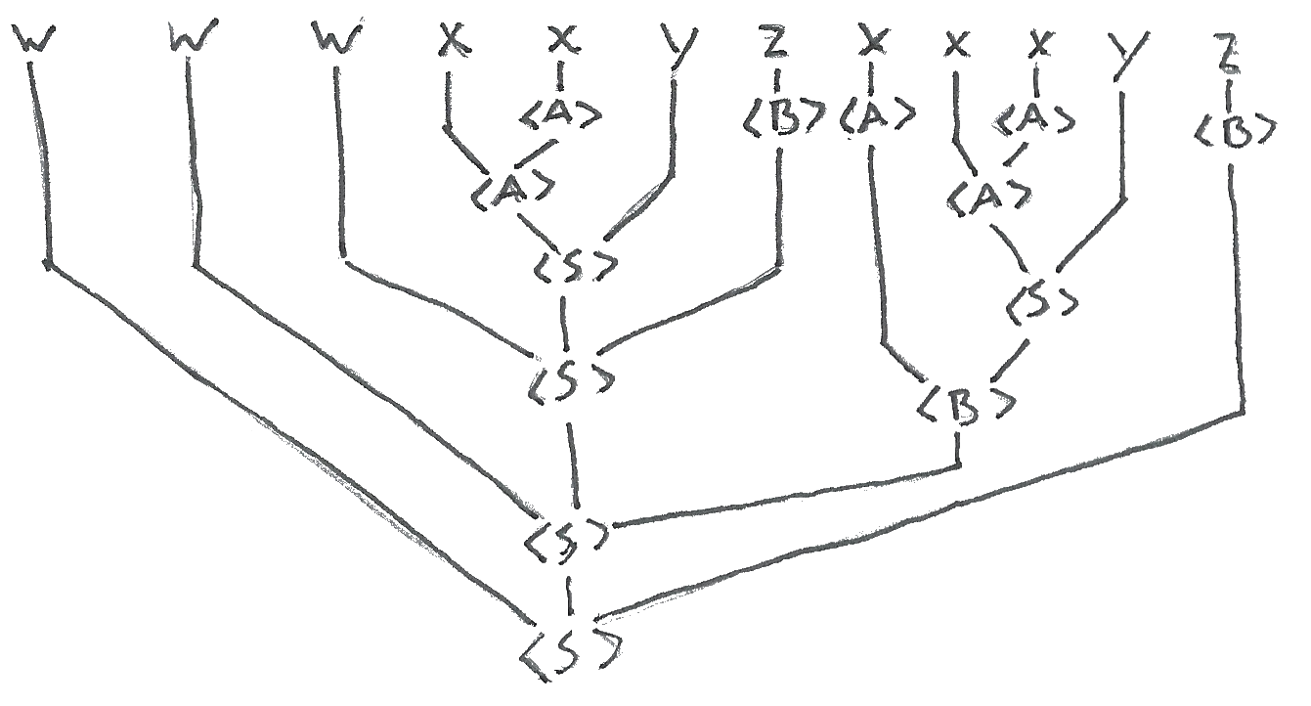

Fig. 2